COOL THINGS ABOUT ANDROID DEVICES

Pay for your coffee
Well this is a very recently introduced idea by Starbucks.There is an Starbucks app on the Google play store that lets you pay for your coffee at Starbucks by your phone itself .To be able to use this service you need to add funds from your cards to the Starbucks app, after which you will only need to swipe your phone to pay for your coffee at Starbucks. This feature has seen very wide acceptance among many services nowadays and very soon it is going to be available everywhere.

Measure your heart beat
You android phone can now be your personal doctor, or at least act like one. Using the Instant Heart Rate app your android phone can now measure your heart rate. The app uses your phones built-in camera to track color changes on the fingertip that are directly linked to your pulse. This is the same technique that medical pulse oximeters use.

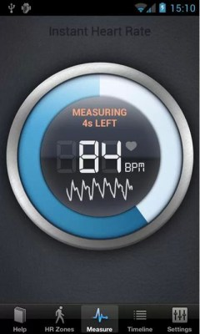
- Control your PC from your phone
Controlling your phone is a very easy task on android. There are many apps for this but I will suggest you my personal favorite , the Team viewer for Remote Control app .The best part it you can even transfer your files from your computer to your phone or vice versa .

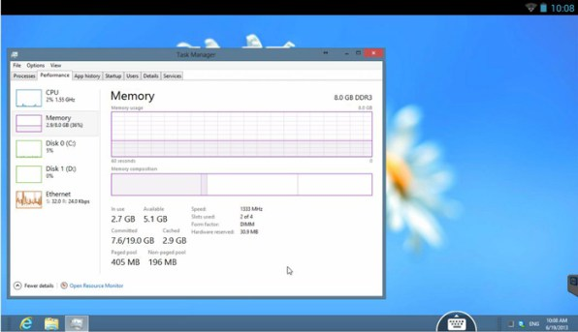

Host your own web server
Android is based on Linux, which means like any Linux device your Android phone can run a full-fledged Web server complete with a mySQL database, PHP support and FTP for file transfers. You can even use this server to host your own website on the internet. KSweb is an Android app that can help you to set up a server on your android phone. This is by far the coolest thing you can do on a android phone.
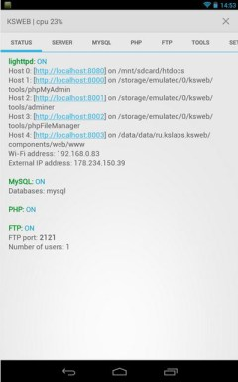

Connect to a USB flash drive
This is a less known thing among most Android users. A android phone can easily use a flash drive as a secondary storage. All you need is an USB OTG cable and a free app, which will enable your Android phone to use flash drive and external hard disk as secondary storage devices. In any case you need to free up some memory from your digital camera, you can use a SD card reader to move files from your camera’s memory card to your phones memory.

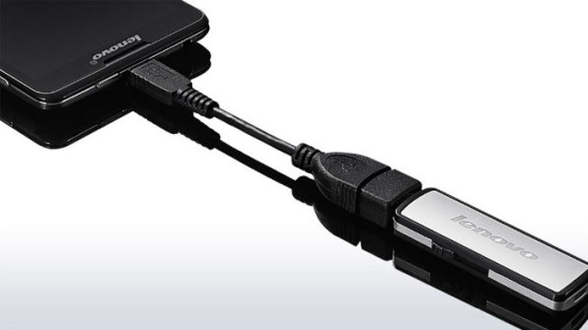

Install desktop Linux on your Android phone
Just as we said before, Android Being based on Linux, they do have many similarities. When an Android phone has enough processing power to run a web server, why can’t it run an entire new OS?. Using a free app called Linux installer you can run operating systems like Ubuntu straight from your phone. You can use a USB OTG cable to connect a keyboard and mouse and you have a full fledged desktop with multitasking capability in your hands. Further you will be able to use all the apps that come pre installed within the OS.

Programming an android app on your phone
You android phone is something similar to and desktop PC, which means you do have the ability to program on your android phone. With Android, you can actually write, compile and test an app directly on your device. AIDE is a free Android app to write programming codes from your android phone itself. It’s the most convenient way of satisfying your programming needs when you’re on the move.

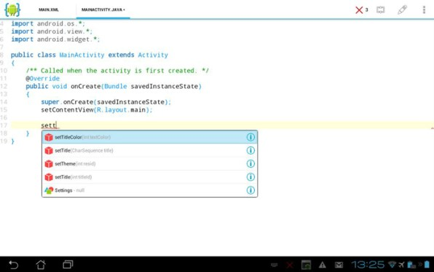

Recognize any monument or place
You might know the popular Eiffel tower but what about the other less known monuments?, You Android phone can help you with that . Google has a free app called Google Goggles, which allows you to capture photographs of monuments and structure and identify them . So next time you’re visiting a new place , you will have your android phone which will provide you more details on any monument than your guide can .Further you can even use the Goggles app to identify monuments from photographs .

Use as a pedometer
Sometimes you might think of why your android phone has so many features like GPS, gyroscope, humidity sensor …etc. Well apart from your phone using these features, there is other app that can take advantage of these features. Using the Accelerometer inside your phone, there are several android apps on the play store which can determine and record how many steps you have taken. One such app is Runkeeper, apart from serving as a pedometer, it combining your BMI data and provide you details about how much calories you burn as you walk .
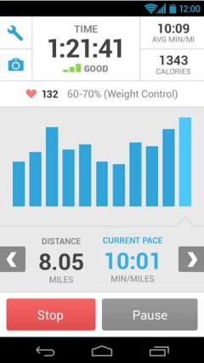

Start your car with your Android phone
Yes, your android phone can be the key to start your car! Regardless of where you are, you might be in another continent and you will still be capable of starting your car wirelessly from miles away. All you need is the Viper Smartstart app and you are all set to through away your clunky car key and the key-chains. Your Android phone is now all you need to start, lock and unlock your car. Apart from the basic features the app has loads of other features.

